Comidas tradicionales

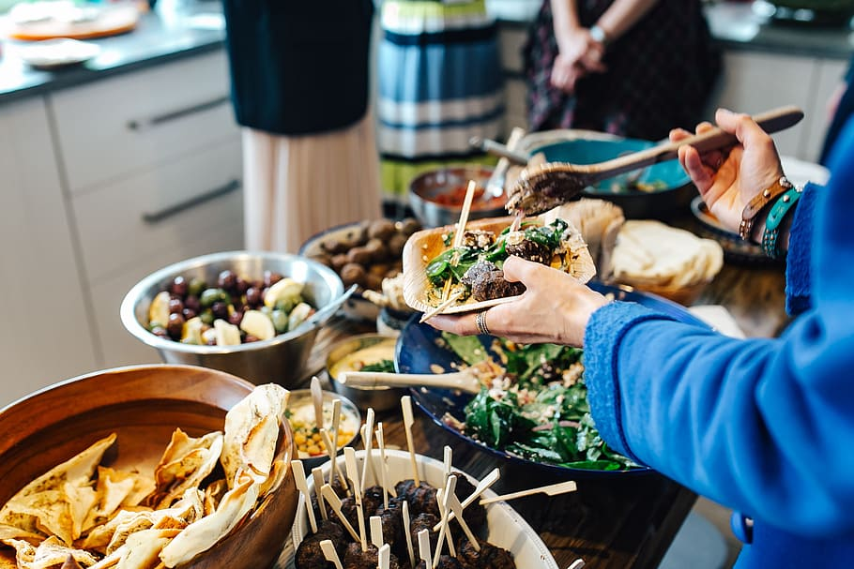

Choose a Spanish-speaking country from the list below and do research on traditional foods enjoyed during spring or summer. It could be a main dish and/or a dessert.

México/ Guatemala/ Honduras/ El Salvador/ Nicaragua/ Costa Rica/ Panamá

España/ La República Dominicana/ Cuba/ Puerto Rico

Venezuela/ Colombia/ Ecuador/ Perú/ Chile/ Bolivia/ Argentina/ Uruguay/ Paraguay

After you have chosen a dish, you will create a Google Slides presentation and share it with emariano@sageridge.org.

The presentation must include:

-a title slide mentioning the country and meal and "por: your nickname" done

-a slide that says which country the dish is from and a map of the country done

-the name of the dish and photos of the dish done

-a slide with the ingredients in Spanish and translation in English in parenthesis (use [www.wordreference.com](http://www.wordreference.com) to look up the ingredients in Spanish) Done

-a slide that explains more about the dish, such as the origins of it, why it is popular and special, etc.

-a slide in which you mention if you would like to try this dish (or not) and why

-a reference slide at the end that has all your citations

(feel free to include more photos of the dish as you see fit)

Rough Draft

Before you create your slideshow, you will research countries and traditional foods online. Once you have decided on a country and dish, make a copy of this, fill it out, and share it with Sra. Mariano so she can look it over and give you feedback. Her email is [emariano@sageridge.org](mailto:emariano@sageridge.org).

1. Highlight the Spanish-speaking country from the list below that you are choosing: México

México/ Guatemala/ Honduras/ El Salvador/ Nicaragua/ Costa Rica/ Panamá

España/ La República Dominicana/ Cuba/ Puerto Rico

Venezuela/ Colombia/ Ecuador/ Perú/ Chile/ Bolivia/ Argentina/ Uruguay/ Paraguay

2. List the name of the traditional food enjoyed during the spring or summer. (It could be a main dish and/or a dessert.) Chiles en nogada

3. List the main ingredients in Spanish and translation in English in parenthesis (use [www.wordreference.com](http://www.wordreference.com) to look up the ingredients in Spanish)

4. Explain more about the dish, such as the origins of it, why it is popular and special, etc. The food consists of poblano chiles with a mix usually containing meat that is shredded, dried fruits and different kinds of spices, with a walnut based creamy sauce that is called nogada, and pomegranate seeds. Which gives it the three colors of the Mexican flag: green from the chili, white from the nut sauce and red from the pomegranate.

5. Mention if you would like to try this dish (or not) and why? I would recommend it to people because it looks very good with sauce and the pepper and it is spicy so that would have a nice texture and I would try it because it looks very good for a meal.

6. Copy/paste the websites you are using to get your information below: <https://www.topuniversities.com/blog/14-amazing-mexican-food-drinks-you-should-try>

[www.wordreference.com](http://www.wordreference.com)

<https://condesarestaurant.com/chiles-en-nogada/#:~:text=Chiles%20en%20Nogada%20is%20a,offering%20at%20many%20Mexican%20restaurants>.

<https://everythingplayadelcarmen.com/chiles-en-nogada-mexican-history-in-every-bite/#:~:text=A%20Little%20History%20of%20Chiles,the%20Mexican%20War%20of%20Independence>.

Google Image Search

<https://mexicanfoodjournal.com/chiles-en-nogada/>

<https://geology.com/world/mexico-satellite-image.shtml>

Rubric /30 pts.

|  | *¡estupendo!*  (exceeds/meets requirement) | *así-así*  (approaches requirement) | *¿qué pasó?*  (does not meet requirement) |
| --- | --- | --- | --- |
| title slide mentioning the country and meal and "por: your nickname"  (3 pts.) |  |  |  |
| slide that says which country the dish is from and a map of the country  (2 pts.) |  |  |  |
| slide with name of the dish and photos of the dish  (4 pts.) |  |  |  |
| slide with the ingredients in Spanish and English in parenthesis  (4 pts.) |  |  |  |
| slide in which you mention if you would like to try this dish (or not) and why  (2 points) |  |  |  |
| reference slide at the end that has all your citations  (4 points) |  |  |  |
| effort/ creativity  (5 pts.) |  |  |  |
| spelling and punctuation  (3 points) |  |  |  |
| audience participation sheet  (3 points) |  |  |  |